NAME : B.ANJALI
REGISTER NUMBER: 192371062
COURSE CODE: CSA0903
COURSE NAME: JAVA PROGRAMMING
1.Write a program to store 15 integer values in an ArrayList and remove all duplicate elements without using another collection.
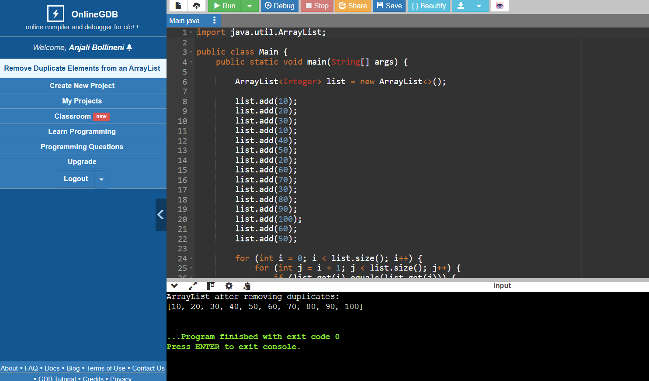
2. Store employee IDs in a LinkedList and display them in both forward and reverse order.
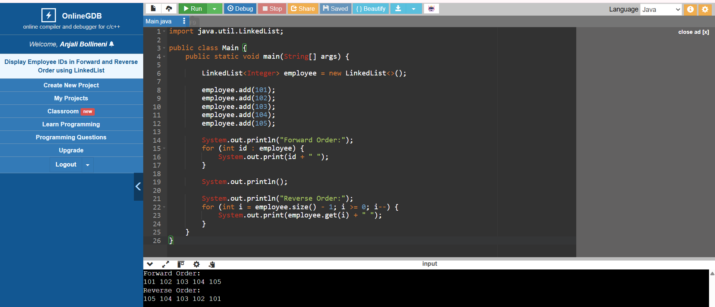

3. Store email IDs entered by the user in a HashSet. Display only unique email IDs and count the total unique entries.
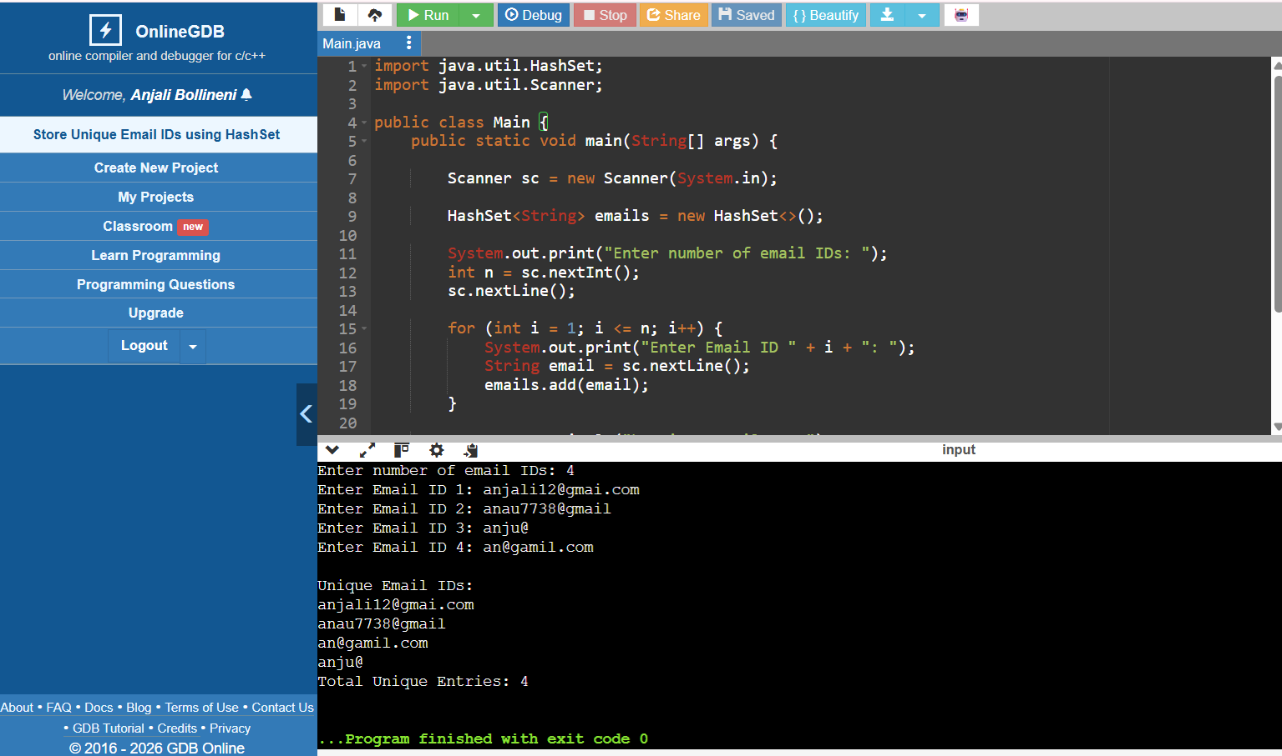
4. Write a Java program to count the frequency of each word in a paragraph using a HashMap.
